|  |  |
| --- | --- |
| **Total Marks:** | **7.5** |
| **Obtained Marks:** |  |

**DATA STRUCTURE**

**AND**

**ALGORITHM**

**Lab Report # 09**

**Submitted To: Mam Tehreen**

**_____________________________________________________________________________________________________________________________________________________________________________________________________________________________________**

**Submitted By**: **Hammad Qureshi**  .

**Reg. Numbers: 2112114**

**______________________________________________________________________________________________________________________________________________________________________________________________________________________________________**

**Question no 1:**

1. **Write a function to sort array elements using quick sort**
2. **Write a function to sort array elements using merge sort**
3. **Write a function to sort array elements using Insertion Sort**

**Code:**

|  |
| --- |
| **Part(a)**  #include<iostream>  using namespace std;  void swap(int arr[] , int pos1, int pos2){  int temp;  temp = arr[pos1];  arr[pos1] = arr[pos2];  arr[pos2] = temp;  }  int partition(int arr[], int low, int high, int pivot){  int i = low;  int j = low;  while( i <= high){  if(arr[i] > pivot){  i++;  }  else{  swap(arr,i,j);  i++;  j++;  }  }  return j-1;  }  void quickSort(int arr[], int low, int high){  if(low < high){  int pivot = arr[high];  int pos = partition(arr, low, high, pivot);    quickSort(arr, low, pos-1);  quickSort(arr, pos+1, high);  }  }  int main()  {  int n ;  cout <<"Enter the size of array ";  cin>>n;  int arr[n];  for( int i = 0 ; i < n; i++){  cin>> arr[i];  }  quickSort(arr, 0 , n-1);  cout<<"The sorted array is: ";  for( int i = 0 ; i < n; i++){  cout<< arr[i]<<" ";  }    }  **Part(c)**  #include<iostream>  using namespace std;    // Function to sort an array using  // insertion sort  void insertionSort(int arr[], int n)  {  int i, key, j;  for (i = 1; i < n; i++)  {  key = arr[i];  j = i - 1;    // Move elements of arr[0..i-1],  // that are greater than key, to one  // position ahead of their  // current position  while (j >= 0 && arr[j] > key)  {  arr[j + 1] = arr[j];  j = j - 1;  }  arr[j + 1] = key;  }  }    // A utility function to print an array  // of size n  void printArray(int arr[], int n)  {  int i;  for (i = 0; i < n; i++)  cout << arr[i] << " ";  cout << endl;  }    // Driver code  int main()  {  int arr[] = { 12, 11, 13, 5, 6 };  int N = sizeof(arr) / sizeof(arr[0]);    insertionSort(arr, N);  printArray(arr, N);    return 0;  }  **Part(c)**  #include <iostream>  using namespace std;    // Merges two subarrays of array[].  // First subarray is arr[begin..mid]  // Second subarray is arr[mid+1..end]  void merge(int array[], int const left, int const mid,  int const right)  {  auto const subArrayOne = mid - left + 1;  auto const subArrayTwo = right - mid;    // Create temp arrays  auto *leftArray = new int[subArrayOne],  *rightArray = new int[subArrayTwo];    // Copy data to temp arrays leftArray[] and rightArray[]  for (auto i = 0; i < subArrayOne; i++)  leftArray[i] = array[left + i];  for (auto j = 0; j < subArrayTwo; j++)  rightArray[j] = array[mid + 1 + j];    auto indexOfSubArrayOne  = 0, // Initial index of first sub-array  indexOfSubArrayTwo  = 0; // Initial index of second sub-array  int indexOfMergedArray  = left; // Initial index of merged array    // Merge the temp arrays back into array[left..right]  while (indexOfSubArrayOne < subArrayOne  && indexOfSubArrayTwo < subArrayTwo) {  if (leftArray[indexOfSubArrayOne]  <= rightArray[indexOfSubArrayTwo]) {  array[indexOfMergedArray]  = leftArray[indexOfSubArrayOne];  indexOfSubArrayOne++;  }  else {  array[indexOfMergedArray]  = rightArray[indexOfSubArrayTwo];  indexOfSubArrayTwo++;  }  indexOfMergedArray++;  }  // Copy the remaining elements of  // left[], if there are any  while (indexOfSubArrayOne < subArrayOne) {  array[indexOfMergedArray]  = leftArray[indexOfSubArrayOne];  indexOfSubArrayOne++;  indexOfMergedArray++;  }  // Copy the remaining elements of  // right[], if there are any  while (indexOfSubArrayTwo < subArrayTwo) {  array[indexOfMergedArray]  = rightArray[indexOfSubArrayTwo];  indexOfSubArrayTwo++;  indexOfMergedArray++;  }  delete[] leftArray;  delete[] rightArray;  }    // begin is for left index and end is  // right index of the sub-array  // of arr to be sorted */  void mergeSort(int array[], int const begin, int const end)  {  if (begin >= end)  return; // Returns recursively    auto mid = begin + (end - begin) / 2;  mergeSort(array, begin, mid);  mergeSort(array, mid + 1, end);  merge(array, begin, mid, end);  }    // UTILITY FUNCTIONS  // Function to print an array  void printArray(int A[], int size)  {  for (auto i = 0; i < size; i++)  cout << A[i] << " ";  }    // Driver code  int main()  {  int arr[] = { 12, 11, 13, 5, 6, 7 };  auto arr_size = sizeof(arr) / sizeof(arr[0]);    cout << "Given array is \n";  printArray(arr, arr_size);    mergeSort(arr, 0, arr_size - 1);    cout << "\nSorted array is \n";  printArray(arr, arr_size);  return 0;  } |

**CONSOLE SCREEN:**

**Part(a)**

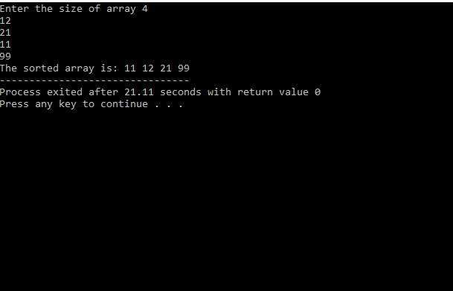

**Part©**

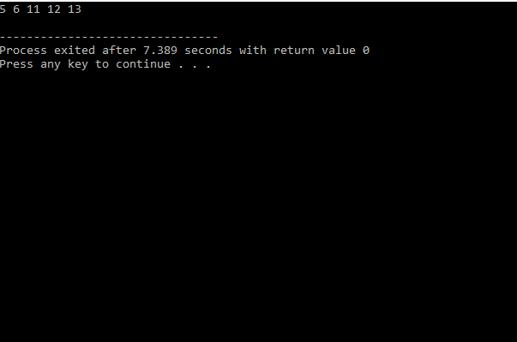

**Part(b)**

